**PRE-DEPARTURE HANDBOOK**



Photo by [Mantas Hesthaven](https://unsplash.com/@mantashesthaven?utm_source=unsplash&utm_medium=referral&utm_content=creditCopyText) on [Unsplash](https://unsplash.com/s/photos/travel?utm_source=unsplash&utm_medium=referral&utm_content=creditCopyText)

Congratulations on your acceptance to your study abroad program! The Office of International Education is pleased to welcome you to Lyon College’s Study Abroad program. Whether you are planning to study abroad on a short-term Nichols International Studies course or to join a longer exchange program overseas, you will receive program-specific orientation information from your trip leader or onsite from your chosen exchange program. This handbook is designed to supplement, rather than to supersede, that information. You can contact your Faculty Trip Leader or The Director of International Education (Ext. 7229) to discuss any study abroad questions/concerns you may have.

**Personal Goals**

The most beneficial study abroad experience is likely to the one that is focused and purposeful. Before you apply to study abroad, give some serious thought to your own particular goals for study abroad and to what you hope to get out of the experience. Some possible goals include the following:

* Explore interests you may have in a particular culture or new region
* Immerse yourself in language study
* Learn more about a possible career path

Deciding your personal goals will help you to choose the best study abroad course for your personal needs and later it will you to stay focused on the kinds of overseas activities which are consistent with your goals. It will also assist you in assessing after the trip how well you have done and what will take away from the experience.

**Prepare**

Advance preparation is the key! Now that you know your program and when it will take place, you should start planning the details of your trip as far in advance as possible.

***Travel Documents***

* Apply for a Passport and/or Visa In order to travel abroad. Your passport must be valid for six months after your return travel date. Remember that if you do not have your passport, you should apply for one immediately. Processing generally takes six weeks but can take longer during the summer peak travel season. Remember also that if you are traveling beyond North America and the Caribbean, you will need a standard passport and not a passport card. Your program leader or the Director of International Education will advise you if a VISA is needed and how to apply for one. For more information about passport and VISA applications visit www.travel.state.gov and click on “U.S. Passports and International Travel”.

* U.S. citizens will have to complete the following steps:

1. Complete & Submit Form DS-11: Application for A US Passport

2. Submit Evidence of U.S. Citizenship- This includes: Previously issued,

undamaged U.S. Passport or Certified Birth Certificate issued by the city,

county or state, or Consular report of Birth Abroad/Certification of Birth,

or Naturalization Certificate /Certificate of Citizenship

3. Present Identification at the Time of Application: This includes:

Previously issued, undamaged U.S. Passport or Naturalization Certificate

or Valid Driver’s License or Current Government ID (city, state or federal)

or Current Military ID

4. Submit a Photocopy of the Document (s) Presented (in Step 3)

5. Pay the Application and Execution Fee- approximately $145, payable by

check, bank draft, cashier's check or money order made payable to the

U.S. Department of State.

6. Provide a Passport Photo. This can be done at stores with photo counters and usually at the office where you present the application (please confirm with location before arrival) Be sure that the photos are clear and that they meet the specifications of the passport office. Make color photocopies of your passport. Leave one copy at home with a trusted family member or friend. While abroad, remember to keep your passport in a safe and secure location. Always carry your passport and/or a photocopy of your passport.

***Other Pre-departure Details***

1. Make copies of your credit card(s) and leave them with family or a friend whom you can contact in case you lose the original(s).

2. International students should google the destination country and “visa requirements” to see what the requirements are for nationals of their home country. Your trip leader or the Director of International Education can assist you with this. Short-term travelers will probably only need tourist visas, which those who are studying overseas for longer periods may need student visas.

3. If you plan to study abroad as part of an exchange, you might try accessing Google Flights, which is a good tool to predict flight rates and suggest lower fares dates Then try to book your flight using via STA Travel because Lyon College books most of its flight via STA and usually gets very good rates from them. We may also be able to provide a contact for the company. Try to book your flight so you land in the morning, as finding your way around in an unfamiliar location will be much easier in daylight.

***Miscellaneous Tips***

* ***Housing***

Secure housing. If you are travelling on a Nichols short-term study abroad trip, this will be taken care of by your program, but if not, booking in advance is the best option. First contact your host university’s international student services office. They should be able to provide a list of student rooms, apartments, and residences, and to give you some suggestions on the best and most cost-effectives ways to commute between your lodging and the university.

* ***Ground Transportation***

For those not traveling with a group, you will also need to research transportation from the airport to your new lodging. Guidebooks, the overseas university’s International Student Services Office, or the Campus Accommodations Office should be able to supply you with information on this. Also, checking the Ground Transportation section of your arrival airport’s website might be helpful.

* ***Cell Phon*e**

For safety and convenience, we recommend that you have a functioning phone while abroad. Consider the following options when planning for mobile phone use:

1. Purchase an international plan for your phone through your current phone provider. This is probably the most expensive option but can be very convenient as you will not have to purchase a phone and/or SIM card on-site.
2. Look into pay-as-you-go phone plans while in country. Is your phone “unlocked” and does your phone have an accessible SIM card slot? If so, you may be able to purchase a SIM card in-country and use it for relatively cheap costs.
3. There are also companies , such as Cellhire in Europe, which rent phones out for about $3/day.
4. Consider using free apps that work through Wi-Fi to connect with family and friends while abroad. This option has limited use as it depends on your access to Wi-Fi. Some apps that you could use include WhatsApp, Google Hangouts, Facebook Messenger, and Skype.
5. Certain smartphones like Android and Iphone, will allow you to activate Airplane Mode (which switches off all of your smartphone’s antennas and wireless transmitters) and Wi-Fi simultaneously. This means you can use wi-fi apps such as IMessage, Facetime Audio, etc. without incurring international charges. Contact your cell phone carrier for additional questions.

* ***Financial Matters***

There are other financial logistics you must consider before you depart. It is recommended that you use a combination of cash, credit and debit cards, traveler’s checks, and ATM cards while abroad. Remember, however, that in some countries ATM’s and credit and debit cards and even traveler’s checks may be options in larger cities but not in other areas. Also, remember to let your credit card company know in advance where and when you will be traveling so that they do not block overseas transactions. You should become familiar with the currency of the country you’re visiting and the exchange rate. Up to date exchange rates can be found at: http://www.x-rates.com/

Additional financial items to consider include:

1. Cash - Purchase foreign currency at your local home bank or currency exchange location before departing. This will allow you to have local currency on hand in case of emergency. We suggest around $300 to start you off. (Usually bills of larger denominations get better rates of exchange.) Avoid Cash Exchange Counters not connected with a bank if you can. Their exchange rates, especially at hotels, are higher than most other locations. Remember to spend all coins before you leave your destination, as most banks and exchange desks will not convert them back to dollars.

2. Cards - Check with your bank about their policy for using credit and debit cards and withdrawing cash from ATMs while abroad. Make sure you understand the foreign currency conversion fees. ATMs are available at many banks. If you plan on withdrawing cash while abroad, try to minimize the bank fees you pay by withdrawing the maximum amount allowed for the lowest fee, instead of making multiple withdrawals of smaller amounts and being the same fee over and over again.

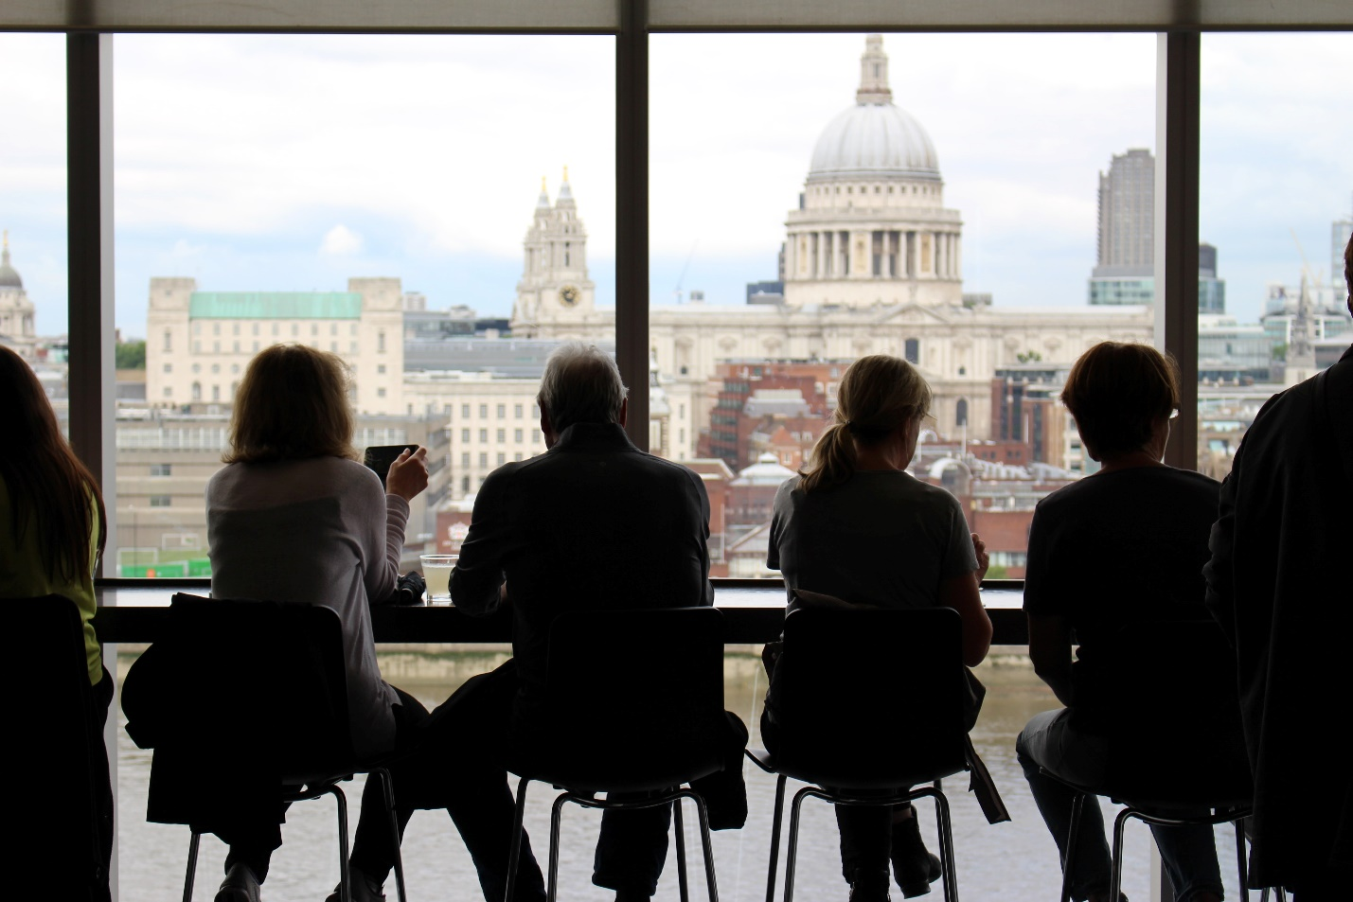

* ***Social/Cultural Matters***

1. Do not assume that the rules of behavior in the place you are going will be the same as those in the United States, even if English is the language of the host country*.* Rather than make social mistakes which could seriously affect how local people see you and interact with you, take thetime to research the local customs and culture. There are several online resources for doing this, such as: <https://www.commisceo-global.com/resources/country-guides>
2. Since local people you meet overseas will tend to see you as a source of information and insight on all things American, it might be worthwhile to brush up on American current events before you leave. Again, there are plenty of online resources and news sites online, as well as magazines such as ***Time*** and ***Newsweek.***

* ***Health Matters*/*General Health Suggestions***

Being healthy and secure are key components to having a positive study abroad trip. It can be difficult to find even commonly used over-the-counter medications while abroad. The following are a few suggestions to help you make sure that your trip is a healthy one:

1. Visit your doctor, dentist, and (potentially) optometrist for a check-up prior to traveling.
2. Obtain all vaccinations required for the host country and other countries you may travel to. (Make sure they apply to the area of the country you will be visiting.)
3. Bring necessary quantities of over-the-counter medications as well as sufficient quantities of prescriptions. Be sure to carry written prescriptions from your Doctor.
4. Pack any over-the-counter you use regularly.
5. Make sure that your Nichols trip leader is aware of any health issues you may have or in exchange/semester abroad programs inform the overseas campus student health service of these issues.

* ***Insurance***

In Nichols programs, unless you produce evidence of equivalent coverage, you will be covered by EIIA and have access to AIG Travel Assist in case of medical emergencies, lost passports, lost luggage, and a variety of other overseas problems you might encounter. To avoid your having to pre-pay and later collect reimbursement for overseas medical care you will also be given and charged for ($25) an ISAC card which includes insurance that will pay costs upfront. The card also entitles you to travel discounts as an international student. If you are not covered by family insurance or by Nichols group insurance (EIIA) purchase student health insurance. Please utilize the below suggestions if applicable: As mentioned above, purchase a health insurance plan. This should be done through your overseas program, (if it offers such an option) but other independent choices are HTH, ASA Inc., Cultural Insurance Services International, World Nomads Insurance, and International Student Protection. Contact the insurance company about extending coverage if you plan to travel before or after your official program dates. Also, obtain a letter confirming full-time student status, if necessary for your private insurance plan. Obtain additional personal property and personal liability coverage, if desired.

* ***Legalities***

There are certain legalities all study abroad participants should consider, especially if you are going on a semester or year-long program:

1. Register with the US State Department STEP Program. The Smart Traveler Enrollment Program (STEP) is a free service to allow U.S. citizens and nationals traveling abroad to enroll their trip with the nearest U.S. Embassy or Consulate.
2. Complete a Power of Attorney form. (samples available online) This is a legal document that gives a designated the authority to act for another person in specified or all legal or financial matters. It is important to have should anything happen, or should someone need to access your bank account on your behalf.
3. Get information about absentee voting, if applicable
4. Get information about filing taxes abroad, if applicable.

* ***Home Support System***

Leaving the country is a great opportunity for growth, not only for you, but your family and friends as well. They will want to be involved in your international experience, especially if you are the first to leave the country! 1-2 months prior to leaving on your trip is a great chance to set expectations for yourself and support system. Use the below talking points to guide your discussion. What are your worries about me going abroad? What can we do to address your concerns? How often will we communicate? Should we set a schedule? Remember this is a time to immerse yourself in another culture and gain more independence. You should consider limiting contact back home. Am I expected/willing to share my experience while abroad? If so, how? Facebook, Blogs, Instagram and Snapchat are great options. Like communication, try to limit social media usage to maximize your new cultural experience. If you have received the emergency procedures from your program, such as how to contact you in case of emergency, share them with your support system.

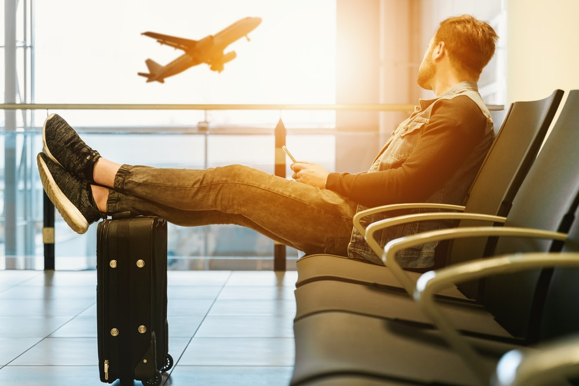

* ***Tips for Packing***

Whether you are going abroad for a week or a semester, packing can be a daunting task. Here are some things to keep in mind as you get ready for your program:

1. Luggage limits

Most airlines have limits on how many bags you can take and how much each bag can weigh. You’ll want to check with your airline, but a general standard for international is one carry-on bag, one checked bag (up to 50 lbs.), and one personal item (such as a purse or bookbag). Remember to leave space to bring back souvenirs!

2. Toiletries

Pack some travel-size toiletries (3.4 oz or less) to last you the first few days of your program. If these items are packed in your carry on, please remember to place them in a one-quart sized transparent bag. Generally larger sizes do not justify the weight and space they take up and can be bought at your destination later.

3. Don’t Overpack

When you are packing, it is easy to think that you need to take every article of clothing you own. You don’t. As a general rule, it is good to lay everything you want to pack out on your bed and then put half of it away.

4. Pack for Your Destination

Every country has different standards of dress and cultural expectations. You’ll want to make sure that the clothes that you pack are both culturally and climate appropriate. In some countries extra care must be taken to dress conservatively when visiting significant cultural/religious sites. Check destination guidebooks for suggestions.

1. Personal Health Kit

Remember to pack items like bandages, first aid ointment, over-the-counter medications stomach like Pepto Bismol, a pain reliever, and sexual health supplies, as well as prescription medicines. To avoid problems with customs, it is also advisable to pack copies of your prescriptions.

Sample Packing List:

Carry-On

Enough clothes to last you 2 days

Passport, visa (if required), and entry letters (if required)

Important documents (arrival instructions, foreign address, local contact information)

Airline tickets

Toiletries (Remember the 3-1-1 rule)

Laptop/tablet and charger (and adapters)

* Cell phone and charger
* Prescription medications in their original containers and prescriptions
* Any over-the-counter medicines you might need
* A pen (You will probably have to fill out customs and landing documents.)
* Headphones
* Collapsible umbrella
* Sunglasses

Checked Bag

* Clothing (Check with Trip Leader and local guidebooks for suggestions.))
* Footwear (comfortable and appropriate options)
* Personal health kit (including but not limited to: bandages, first aid ointment, over-the-counter medications stomach like Pepto Bismol, a pain reliever, sexual health supplies)
* Other program specific items (covered in your orientation)

***Conclusion***

This guide accessed a variety of online sources and the experience of the author in gathering information to help you prepare for your great adventure overseas. It does not claim to be an exhaustive source of all the details you will need for study abroad. Use it as one resource among many in researching what you need to know to make the best of your study abroad. Also access country guides books, online resources, trip leaders, study abroad staff, and any all other available sources of information to help you in your preparation. As stated previously, extensive and careful preparation is essential for effective overseas travel and study.

As with most experiences in life, the benefits of study abroad will be determined by both the mindset you bring to it and the effort you put into it. Approach the experience with openness and a willingness to learn, to try new things and to reflect on differences and similarities you encounter overseas, and you will get the most out of study abroad. Make the extra effort to engage with the people and the culture of the place you are visiting, to respect and understand other ways of thinking and doing things, and you will return home with a greater appreciation of the richness of the world you live in and a greater understanding of your own culture and how it compares with others.

