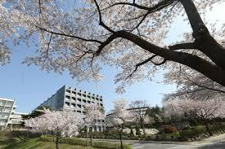
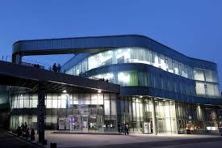
Myongji University

City and University
Myongji University is a private, Christian university founded in 1948 in South Korea. It provides higher education in the fields of engineering, sciences and humanities. It has two campuses: the Social Science Campus is located in Seoul and the Natural Science Campus is in Yongin which is 35 kilometres (22 mi) south of the capital. The English-language version of the University’s brochure for international students can be found at http://abroad.mju.ac.kr/user/oia/download/2019_eng.pdf and their university website at https://www.mju.ac.kr/us/index..do
Yongin (Korean pronunciation: [joŋ.in]) is a major city in the Seoul Capital Area, located in Gyeonggi Province, South Korea. With a population close to 1 million, the city has developed rapidly since the 21st century, recording the highest population growth of any city in the country. Yongin is home to Everland and Caribbean Bay, South Korea's most popular amusement and water parks. The city is also home to the Korean Folk Village, the largest of its kind.
With over 22,000 undergraduates and 2,600 postgraduates, Myongji University has been a center for practical humanism over the past half century, and is operating various and practical globalization programs while having exchanges with 150 universities in 22 different countries.
Myongji University set off as Seoul Primary College of Home Economics, established by Moo-gung Institution in 1948 and in 1953, established Geunhwa Women's Primary College. On September 13, 1994, the Arts and Design Center was built in industry-academia cooperation of Myongji University and Nasan Group. Myongji University had a New Millennium Proclamation Ceremony to foster a creative epistemic community that will lead 21st century's Korea and to cope with rapidly changing university environments. It is also taking off to be a university living Christian faith, creativity, innovation, action and a university that becomes the power of future society.

Courses
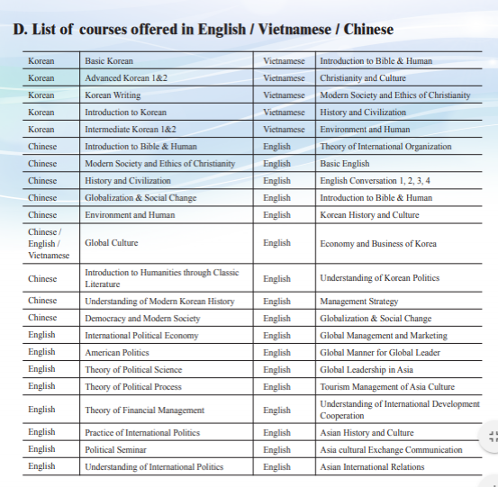
Myongji University offers a variety of courses in English/ Vietnamese and Chinese.
Additionally, there is a List of Majors in Myongji on Both Seoul Campus and Yongin Campus.

Application Deadlines
- For 2020 Fall : 2020 May 31
- For 2021 Spring : 2020 November 30

Application Procedure
Student contacts the international office of his/her home university to start the application procedure.
- The home university’s international office reviews the application documents.
- The home university’s international office emails the application documents to by the end of May.
- MJU screens the application documents.
- MJU issues the Certificate of Admission, Letter of Acceptance and other related materials by mid- July. (post mailed to the international office of the student’s home university).
- Students apply for a visa in his/her home country, purchase a flight ticket and insurance.

For specifics, please see the University’s guidelines for exchanges at
file:///C:/Users/joseph.macade/Downloads/MYONGJ_1%20(1).PDF

Room and Board Costs
The Dormitory Building in Seoul Campus was built in 2006, a 9-story building with a capacity of 864 students with 309 rooms. There are five Dormitory Buildings in Yongin Campus which can host 1,872 students. Each room is equipped with beds, closets, desks, shelves, a telephone, LAN system, air conditioning and refrigerators. Also TVs are equipped in the lounges, and microwaves, electric burners & kettles in the kitchen for simple cooking. Various subsidiary facilities are also available including a laundry room, a seminar room and a convenience store.
Campus | Rooms | One Semester | Vacation
 |  |  | 4 weeks | 8 weeks | Per day
Seoul Campus (Meals not included) | Double (2 beds) | 1,130 USD | 260 USD | 500 USD | 16 USD
 | Quadruple (4 Beds) | 820 USD | 200 USD | 370 USD | 13 USD
Yongin Campus ( 20 meals included) | Double (2 beds) | 960 USD | - | - | 15 USD
 | Quadruple (4 Beds) | 710 USD | - | - | 10 USD

The University provided the following information in regards to accomodations on both Seoul and Yongin campuses:

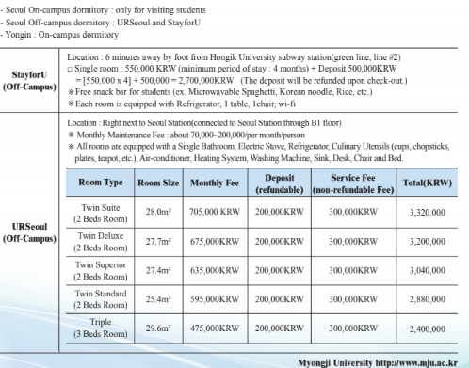
Rent Per Month
- Apartment (1 bedroom) in City Centre $540.42
- Apartment (1 bedroom) Outside of Centre $372.61
- Apartment (3 bedrooms) in City Centre $1,385.85
- Apartment (3 bedrooms) Outside of Centre $890.12

Sample Cost of Living Prices for Seoul (as of June 2020 from https://www.numbeo.com/cost-of- living/compare_countries_result.jsp?country1=South+ Korea&country2 =United+States&displayCurrency=USD)
Restaurants
- Meal, Inexpensive Restaurant $5.97
- Meal for 2 People, Mid-range Restaurant, Three-course $33.66
- McMeal at McDonalds (or Equivalent Combo Meal) $5.18
- Domestic Beer (1pint draught) $3.37
- Imported Beer (12 oz small bottle) $4.21
- Cappuccino (regular) $3.76
- Coke/Pepsi (12 oz small bottle) $1.41
- Water (12 oz small bottle) $0.71

Markets
- Milk (regular), (1 gallon) $7.62
- Loaf of Fresh White Bread (1 lb) $2.22
- Rice (white), (1 lb) $1.61
- Eggs (regular) (12) $2.63
- Local Cheese (1 lb) $7.41
- Chicken Breasts (Boneless, Skinless), (1 lb) $3.91
- Beef Round (1 lb) (or Equivalent Back Leg Red Meat) $11.65
- Apples (1 lb) $2.83
- Banana (1 lb) $1.67
- Oranges (1 lb) $2.28
- Tomato (1 lb) $2.55
- Potato (1 lb) $1.64
- Onion (1 lb) $1.15
- Lettuce (1 head) $2.16
- Water (1.5 liter bottle) $1.13
- Bottle of Wine (Mid-Range) $12.96
- Domestic Beer (0.5 liter bottle) $2.12
- Imported Beer (12 oz small bottle) $2.62
- Cigarettes 20 Pack (Marlboro) $3.67

Transportation
- One-way Ticket (Local Transport) $1.05
- Monthly Pass (Regular Price) $46.28
- Taxi Start (Normal Tariff) $2.95
- Taxi 1 mile (Normal Tariff) $1.08
- Taxi 1hour Waiting (Normal Tariff) $10.10
- Gasoline (1 gallon) $4.88

Utilities (Monthly)
- Basic (Electricity, Heating, Cooling, Water, Garbage) for 915 sq ft Apartment $140.18
- 1 min. of Prepaid Mobile Tariff Local (No Discounts or Plans) $0.13
- Internet (60 Mbps or More, Unlimited Data, Cable/ADSL) $22.45

Sports And Leisure
- Fitness Club, Monthly Fee for 1 Adult $55.11
- Tennis Court Rent (1 Hour on Weekend) $19.55
- Cinema, International Release, 1 Seat $8.41

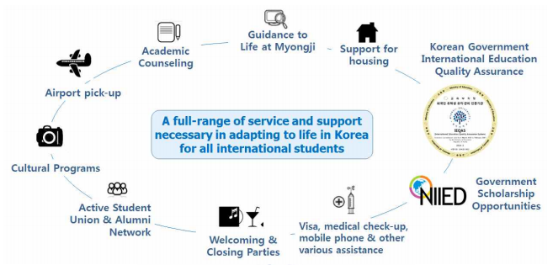

Services Provided to the International Students

Visa Information
Studying abroad provides the perfect opportunity for college students to break their cultural boundaries and experience a whole new part of the world. South Korea makes for an ideal study abroad destination, offering its visitors a rich history, vibrant festivals, decadent cuisine and beautiful scenery. American students who want to study abroad in South Korea have to wrangle a student visa from the South Korean government if they plan to pursue an academic program longer than 90 days.

Visa Application Requirements
Once you've received an official acceptance letter from your university in South Korea, it's time to get started on the visa application process. Students and tourists applying for a Korean visa must do so in person at the Korean consulate with jurisdiction over their home area. For Americans seeking a tourist visa from the consulate, make sure to bring the following application materials:
- Form No. 34 (student visa application form)
- Your passport (which must be valid for at least six months after your expected departure date from South Korea)
- A photocopy of your passport
- A color photo of yourself
- The application fee of $66.55 (subject to change)
- A copy of the Business Registration Certificate of the Korean university (which the university will mail to you upon your acceptance)
- Your acceptance letter from the Korean university (which the school will mail to you, as well)
- Proof of finances to cover the living costs for your time studying in Korea (e.g., a bank statement showing you can cover at least your room and board fees)
- A recommendation letter from your home university
- Proof that you've completed at least one semester at your home university (e.g., an official transcript)
Note that you must have obtained your student visa by the time your semester in South Korea begins, or Korean Immigration Service may fine you. Also keep in mind that, per student visa requirements, you must leave Korea within a week of your semester ending. Again, if you fail to do so, Immigration Service may impose a heavy fine.
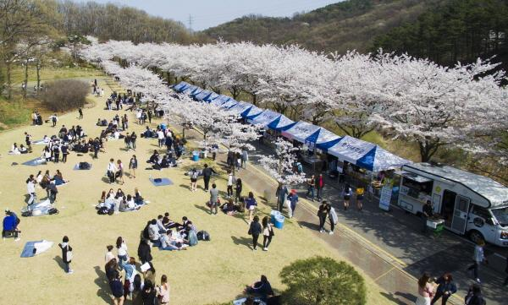
Myongji University WordPress.com

Other Tips to Note
You may apply for your student visa between 30 to 90 days prior to your departure to South Korea. Some Korean consulates require appointments for student visa applicants, so make sure to check with your local consulate to see what it mandates before making the trip to submit your application. Keep in mind that when you submit your student visa application to the Korean consulate, the consulate will keep your passport until your application's been approved.
Once you arrive in South Korea to begin your semester, apply for an alien residence card. This card will permit you to travel from Korea during your time there, and your host university should help you obtain the card once you've arrived in South Korea. If you don't register as an alien resident for a stay in Korea of more than 90 days, Immigration Service may impose consequences. Korean Consulates in the United States *Content from http://abroad.mju.ac.kr/user/oia/download/2019_eng.pdf and https://www.mju.ac.kr/us/index..do

