Irish American Scholars Program

Student Opportunity for a Tuition Free Semester of Study in Northern Ireland

Sponsored by
Association of Presbyterian Colleges and Universities United Methodist Church-Related Colleges and Universities
University of St. Thomas Houston (Catholic Colleges and Universities)

In cooperation with
Queens University Belfast Ulster University St. Mary’s University College Stranmillis University College Belfast Metropolitan College

In association with STUDY USA of Northern Ireland

Participating Northern Ireland Institutions

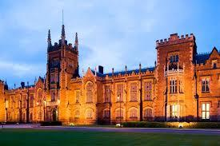
Queens University Belfast - Stock image

Queens University Belfast is one of the 20 top research-intensive institutions in the United Kingdom. While the university does not offer courses in all disciplines, most U.S. students will find appropriate subjects at Queens University. www.qub.ac.uk

Ulster University has a national and international reputation for excellence. With four distinct campuses across Northern Ireland, students are placed at a specific campus based on their field of study. www.ulster.ac.uk
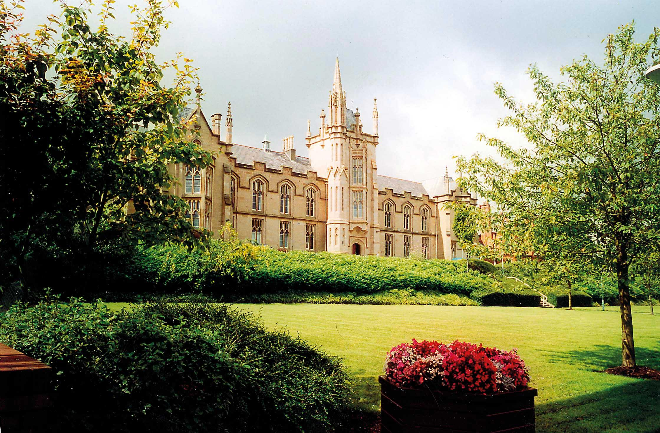

Ulster University Historyireland.com

St. Mary’s University College specializes in liberal arts and teacher training, and is a part of the larger Queen’s University system. In 2011, St. Mary’s was ranked third amongst all universities in the United Kingdom for student satisfaction with their overall university experience. www.stmarys- belfast.ac.uk

Stranmillis University College is highly recognized for its teacher training curriculum, but also offers courses in early childhood and health and leisure studies. Stranmillis is a college within the system of Queen’s University Belfast. www.stran.ac.uk

Stranmillis University College istock.com

Belfast Metropolitan College specializes in educating students with strong career goals in vocational areas such as business, marketing, computing, performing arts, communication and Irish studies. www.belfastmet.ac.uk

Limitations
Schools in Northern Ireland limit the number of students they accept as Irish American Scholars. Acceptance is generally determined by space availability and by a student’s GPA. Students who apply for a full year may be offered only one semester because of space limitations. In addition, there are generally fewer opportunities to place students during the spring semester.

Grade Point Requirement
A minimum cumulative GPA of 3.20 on a 4.00 scale is required. No exceptions. (This is a highly competitive program and no student from Lyon has ever been accepted with less than a 3.50 GPA.)

Application Process
Students must be nominated by their home institution and submit all application materials by February 1, including:
- Completed application & nomination forms.
- An official academic transcript through the fall semester of the current academic year.
- A 500-word essay describing the applicant’s educational objectives while studying in Northern Ireland. (Students should determine in advance that their intended course of study is offered at the institutions they select.)
- Two letters of recommendation – one from the student’s academic adviser and one from another faculty member or administrator at the applicant’s home institution.

Student Housing
Each of the partner universities has an accommodation office which offers information on university and off-campus housing options. In general, university housing is cheaper than off-campus. See the document titled “Queens University Housing Rates” to see prices for various accommodation options.

The following are links to housing information for the partner universities:
Ulster University - https://www.ulster.ac.uk/accommodation
Queen’s University - https://www.qub.ac.uk/accommodation/student-accommodation/student-accommodation-belfast/ and https://qubsu.org/AdviceSU/Accommodation/
Stranmillis University - https://www.stran.ac.uk/accommodation/
Belfast Metropolitan College - Internationalstudents'accommodationGuideofBMC.pdf
St. Mary’s University College - https://www.qub.ac.uk/accommodation/student-accommodation/student-accommodation-belfast/ and https://qubsu.org/AdviceSU/Accommodation/

Additional information can be fund at the Irish American Scholars website at https://irishamericanscholars.com/living-and-studying-in-northern-ireland/ and specific questions can be directed to Ms. Janna Wofford at janna.wofford@presbyteriancolleges.org

If the housing option you choose offers a self-catering option, you can sign up for a meal. If you choose a homestay, you can also pay to have your meals included. If you select an apartment or shared apartment, you shop and prepare your own meals The cost of living guide below will give you some idea of food prices in Belfast as of May 2020:
Cost of Living/Belfast

Restaurants
Meal, Inexpensive Restaurant | $14.64
Meal for 2 People, Mid-range Restaurant, Three-course | $51.86
McMeal at McDonalds (or Equivalent Combo Meal) | $ 7.32
Domestic Beer (1 pint draught) | $ 5.12
Imported Beer (12 oz small bottle) | $4.88
Cappuccino (regular) | $3.25
Coke/Pepsi (12 oz small bottle) | $1.83
Water (12 oz small bottle) | $1.50
Markets
Milk (regular), (1 gallon) | $4.03
Loaf of Fresh White Bread (1 lb) | $1.12
Rice (white), (1 lb) | $0.49
Eggs (regular) (12) | $2.17
Local Cheese (1 lb) | $3.65
Chicken Fillets (1 lb) | $2.95
Beef Round (1 lb) (or Equivalent Back Leg Red Meat) | $3.72
Apples (1 lb) | $0.98
Banana (1 lb) | $0.47
Oranges (1 lb) | $1.14
Tomato (1 lb) | $0.82
Potato (1 lb) | $0.71
Onion (1 lb) | $0.68
Lettuce (1 head) | $0.98
Water (1.5 liter bottle) | $1.13
Bottle of Wine (Mid-Range) | $9.76
Domestic Beer (0.5 liter bottle) | $2.26
Imported Beer (12 oz small bottle) | $2.51

Transportation
One-way Ticket (Local Transport) | $2.56
Monthly Pass (Regular Price) | $70.77
Taxi Start (Normal Tariff) | $3.66
Taxi 1 mile (Normal Tariff) | $1.96
Utilities (Monthly)
Basic (Electricity, Heating, Cooling, Water, Garbage) for 915 sq ft Apartment |  |  | $91.74
1 min. of Prepaid Mobile Tariff Local (No Discounts or Plans) |  |  | $0.09
Internet (60 Mbps or More, Unlimited Data, Cable/ADSL) |  |  | $33.42
Sports and Leisure
Fitness Club, Monthly Fee for 1 Adult |  |  | $30.97

Rent Per Month
Apartment (1 bedroom) in City Centre | $768.44
Apartment (1 bedroom) Outside of Centre | $547.67

More information about the Irish American Scholars Program, as well as the
nomination and application forms, can be found on our website:
www.irishamericanscholars.com

