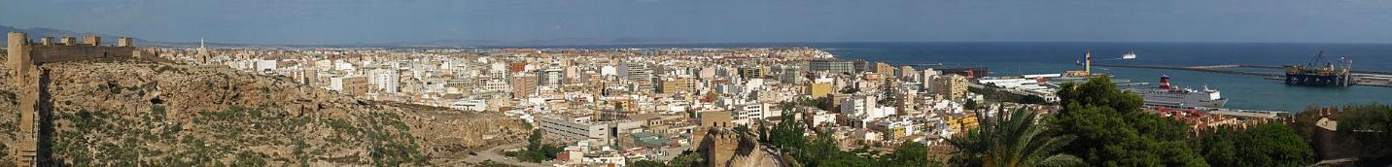Panorama of Almeria City From Wikimedia Commons by Elemaki
There are many reasons to choose the UAL: The UAL´s facilities and equipment are, without doubt, among the most modern in Europe. Highly-skilled teaching staff enjoys cutting-edge technology to teach subjects. Language courses are offered in summer, fall, and spring. Programs at Almeria are accessible either through CONAHEC (spring, fall) or ISEP (fall, spring, summer).
Life on Campus is as enjoyable due to Almeria’s natural environment and pleasant, sunny weather. There are many opportunities for participation in outdoor activities, including aquatics, hiking, and cave explorations. But what makes a stay really successful is the Andalusian character and lifestyle: friendly, cheerful, enterprising and proud of their homeland and customs.
For more details, please see the University’s International Student Guide at https://www.ual.es/application/files/3915/9048/9877 /Guide_2020_2021original.pdf
Basic information on housing can be obtained at https://www.ual.es/en/vida-universitaria/alojamiento?idioma=en_GB
Additional information for new students is available at https://www.ual.es/en/comunidad/estudiantes-internacionales?idioma=en_GB
For those planning on staying in Spain longer than 90 days the following link contains instructions on applying for a student visa. The closest consulate is in Houston at
1800 Bering Drive, Suite 660, Houston. Texas 77057, USA.
Telephone: +1 (713) 783-6200
Email: cog.houston@maec.es
Website: http://www.exteriores.gob.es/Consulados/HOUSTON/en/Pages/inicio.aspxe:

COST OF LIVING
Information from https://www.numbeo.com/cost-of-living/in/Almeria?displayCurrency=USD (Prices as of May 2020)
Restaurants
Meal, Inexpensive Restaurant |  | $11.26
Meal for 2 People, Mid-range Restaurant, Three-course |  | $39.41
McMeal at McDonalds (or Equivalent Combo Meal) |  | $9.01
Domestic Beer (1pint draught) |  | $2.53
Markets
Milk (regular), (1 gallon) | $3.28
Loaf of Fresh White Bread (1 lb) | $0.96
Rice (white), (1 lb) | $0.54
Eggs (regular) (12) | $1.67
Apples (1 lb) $ 0.85
Banana (1 lb) $ 0.64
Oranges (1 lb) $ 0.77
Transportation
One-way Ticket (Local Transport) | $1.18
Monthly Pass (Regular Price) | $36.65
Taxi Start (Normal Tariff) | $2.25
Taxi 1 mile (Normal Tariff) | $1.49
Rent Per Month
Apartment (1 bedroom) in City Centre |  | $439.16
Apartment (1 bedroom) Outside of Centre |  | $358.93
Utilities (Monthly)
Basic (Electricity, Heating, Cooling, Water, Garbage) for 915 sq ft Apartment |  |  | $120.14
1 min. of Prepaid Mobile Tariff Local (No Discounts or Plans) |  |  | $0.15
Internet (60 Mbps or More, Unlimited Data, Cable/ADSL) |  |  | $47.58

