Application Process & Deadlines
Students interested in attending AIU must complete and submit a Lyon College Study Abroad Application to the Office of international Education. The Director of international Education will then nominate qualified students, usually a maximum of two per semester, to Akita University. Once the nominations have been accepted, AIU will send a link to accepted students so that they may complete Akita International University’s application paperwork. In the final step in the process the Director of International Education will send paper copies of the Akita application to Akita University.
Akita accepts students in fall, spring and summer. Nominations for the fall are normally due by the end of February, for spring by the end of September, and for summer in late February with application materials due in Akita by the middle of March.
Once a student has been accepted and after the initial deposit has been made, Akita International University will send a certificate of eligibility. Each accepted student must include the certificate in their application to the Japanese Consulate for a visa. The nearest consulate is in Nashville and the application can be submitted by mail. Instructions are at https://www.nashville.us.emb-japan.go.jp/itpr_en/00_000379.html . The Akita website also has some information regarding visas at https://web.aiu.ac.jp/en/short-term/semester-year-programs/visa/
The University requires that students be insured,( https://web.aiu.ac.jp/en/short-term/semester-year-programs/insurance/ )but their require can be met securing an ISIC international student i.d. and the insurance which goes with the card.
Student Services
Because it hosts so many international students each year, Akita International University has well-developed student support systems. For example, it has two Incoming Student Coordinators who oversee the integration of new students into the Akita community. All questions relating to assistance in transitioning into the University can be directed to them. There are also academic support services available as needed. There is even an office which will assist interested students in finding community activities and service learning opportunities. Many student activities at Akita take place under the auspices of student clubs. A list of clubs can be found at https://web.aiu.ac.jp/en/campuslife/clubs/

Courses
The Akita International University curriculum is divided into five categories:
- Japan Studies courses
- Japanese Language courses
- Basic Education courses(*)
- Global Business Program(*)
- Global Studies Program(*)

Since all courses are taught in English, international students are welcome to take any subject matter course in our curriculum. (Some Preparatory English, English for Academic Purposes, and Study Abroad preparation courses, as well as capstone seminars are restricted to degree-seeking students. Please see the "Course Offerings" link at https://web.aiu.ac.jp/en/academic/course-offerings/for further information.) Detailed syllabi for various classes can be searched for at https://csw.aiu.ac.jp/campusweb/ex/en/syllabus If you have additional questions which are not answered by the online links, you are welcome to route them to Akita International University via the Lyon College Office of International Education.

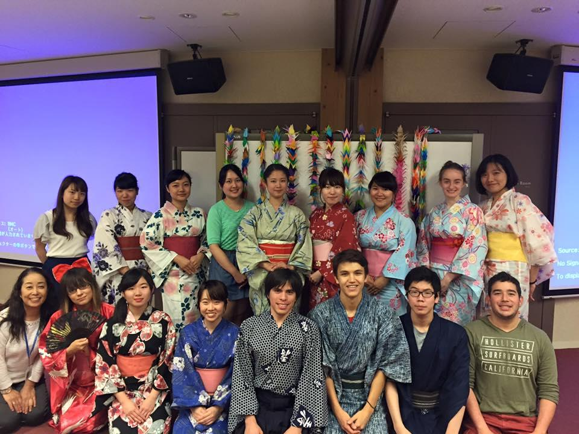

Program Costs:

 | Student Costs for AIU
Fees (per semester) |  | Exchange Students
Admission |  | N/A
Tuition |  | N/A
Room* |  | 90,000 - 184,000 JPY |  | $840 - $1718
Bedding & Cleaning |  | 20,000 JPY |  | $187
Mandatory Meal  (for the first two weeks) |  | 14,670 JPY |  | $137
Semester Meal Plan  (maximum) |  | 102,690 JPY |  | $959
Deposit |  | 20,000 JPY |  | $187
Student Activity |  | 20,000 JPY |  | $187
Total |  | 361,360 JPY(Maximum) (US$3367 as of 05/15/200) |  | Exchange as of 05/17/2020
*Residence on campus required.

        - Table 2: Other Expenses (per semester)
Expected Expenses (per semester) | Estimated Amount
Travel Expenses to Japan | 100,000 JPY - 200,000 JPY $934 - $1868  (varies depending on the location of your home country)
Textbooks | 15,000 JPY - 50,000 JPY $140 - $487
Personal Expenses | 150,000 JPY - 250,000 JPY $1400 - $2334  (varies depending on your lifestyle)
Total | 265,000 JPY - 500,000 JPY(US$2469-$4660)

Sample Off-Campus Costs
Fast-food Meal $6.07

Ordinary Restaurant Meal $42.04 (2 people)

Banana (01 Kg) $3.23

Oranges (1lb.) $0.85

Milk (1 gallon regular) $6.72

A Cup of Coffee (Regular) (Regular/Cup) $1.19

Water (12 oz small bottle) $1.12

Domestic Beer (1 pint draught) $4.20

Coca/Pepsi (0.33 Litre Bottle) $2.62

Taxi (Initial Fare) $2.39 + $3.60 per mile

Sources: https://www.costtotravel.com/living-cost/asia/akita-japan and https://www.numbeo.com/cost-of-living/in/Akita-Japan

